**AHVAP Logo and Branding Specifications Policy**

**Purpose**

The logo specifications policy describes the logo and defines general classes of acceptable and prohibited use. It also defines the color pigmentation used for the Association of Healthcare Value Analysis Professionals (AHVAP) graphics. It does not attempt to define every imaginable use of the logo but provides a clear path to seek approval for variations on the standard logo and its permitted variations.

1. The AHVAP organization logo, the AHVAP annual conference logo and the CVAHP logo are valuable assets**.** To ensure recognition and awareness it’s important to comply with visual guidelines.
2. AVAHP’s graphic identity strengthens the organization's name and image via a distinctive mark applied consistently throughout all organization events, publications, and activities.
3. AHVAP’s management firm shall be the source of the official AHVAP organizational logos.
4. AHVAP logo description and specifications
   1. AHVAP Organizational Logo
      * The graphic element is a slanted stack of 9 circles positioned to the left of the organization’s acronym: AHVAP. *See Appendices for the graphic.*
      * The graphic symbol is blue
      * Font is Candara black.
      * The organization’s name appears directly below the graphic symbol and acronym.
5. AHVAP Annual Conference Logo

* Logo may vary based on theme and location of the annual conference.
  + - The conference logo font size may be adjusted to conform to available space as determined by members of the Conference Committee and with approval by the AHVAP Board of Directors.

1. CVAHP (Certified Value Analysis Healthcare Professional) Logo
   * + The CVAHP certification logo displays the acronym in blue preceded by a blue circle containing the image of the four AHVAP pillars in green. The words “Certified Value Analysis Professional” in a white font appear in a rectangular blue field beneath the acronym. The AHVAP logo appears within the letter C of the acronym. The CVAHP logo font size and design format may be adjusted to conform to the available space and application as determined by members of the CVAHP Committee and with approval by the AHVAP Board of Directors.

*Note: See appendices for web color conversion to printed colors and picture graphics of the organizational, conference, and CVAHP logos.*

1. Usage
   1. Organizations authorized by AHVAP to use the conference logo must display the logo as provided by the Association’s management company.
   2. The Organizational logo shall be displayed on all publications used for AHVAP business, e.g. letterhead, on all AHVAP documents and brochures and for electronic communications such as e-blasts and newsletters and slide templates.
   3. The following guidelines shall apply to the conference logo:

* Proper use of the conference logo will incorporate both the graphic and text elements. It is understood, however, that certain uses of the conference logo preclude the inclusion of the text element. For example, use of the conference logo on a pin or badge, or on the spine of a book may necessitate the use of the graphic element alone. Wherever possible, however, the graphic and text elements should be used together.
* It is understood that certain design opportunities may necessitate the use of the conference logo without the text.
* Decoration of the conference logo is acceptable as long as the basic logo remains clearly visible.
* Conference logo colors and text do not need to be confined to the AHVAP color and text definitions.
  1. The following guidelines shall apply to the AHVAP Organizational logo:
  + The typeface of the AHVAP organizational logo shall not be altered or replaced with another.
  + The proportions of the AHVAP organizational logo shall be retained.
  1. AHVAP Board of Directors or the Association’s management firm will authorize use of the logo in the following circumstances.
* Individuals may use the logos to acknowledge their membership in the organization and/or their participation in a sponsored event.
* Entities associated with the organization or annual conference receive authorization to use the organization or conference logo, as appropriate, to promote their events and/or describe their activities.
* Third parties, such as news organizations, may be authorized to use the logos for promotional purposes.

6. AHVAP Officers and members are authorized to use the logos as well as the copyrighted Value Analysis Statement of Purpose as a signature line in their correspondence. See appendix.

03/2019________________________________ (MM/YYYY)

Revision/Review Approval Date

10/2016 (MM/YYYY)

Date approved by AHVAP Board of Directors

**Appendices A. AHVAP color pigments**

1. **AHVAP Logo**

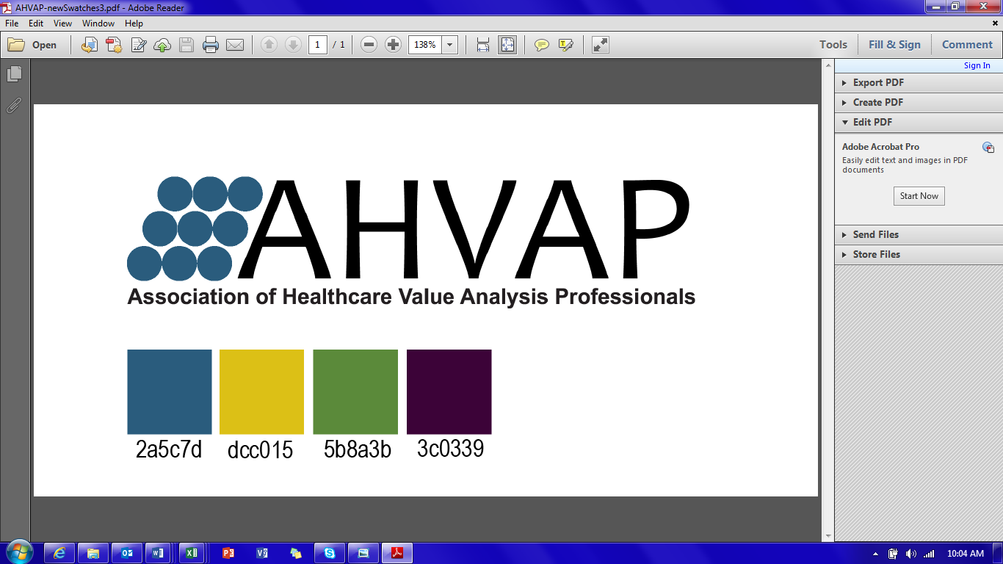

1. **AHVAP Conference Logo**

May vary based upon location and theme eech year.

1. **CVAHP Logo**



1. Signature examples:

1. Name                          **|** Marketing Committee Chair

Email address

Phone #

[www.ahvap.org](http://www.ahvap.org)

Description: Description: Teal AHVAP Logo

*“Healthcare value analysis contributes to optimal patient outcomes through an evidenced-based systematic approach to review healthcare products, equipment, technology and services.  Using recognized practices, organizational resources collaborate to evaluate clinical efficacy, appropriate use and safety for the greatest financial value.©”*

2. **Name      CVAHP** **|** President

Email address

Phone #

[www.ahvap.org](http://www.ahvap.org)

Description: Description: Teal AHVAP Logo****

*“Healthcare value analysis contributes to optimal patient outcomes through an evidenced-based systematic approach to review healthcare products, equipment, technology and services.  Using recognized practices, organizational resources collaborate to evaluate clinical efficacy, appropriate use and safety for the greatest financial value.©”*

1. **Hexadecimal color (for web design)**

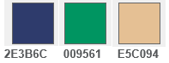

1. **Converting Hexadecimal to ‘RGB’ (for computer and printing use)**
2. Blue 2E3B6C to RGB [R=46, G=59, B=108].
3. Gold E5C094 [R=229, G=192, B=148]
4. Green 009561 to RGB [R=0, G=149, B=97]